Making the Internet Safer for Children and Families
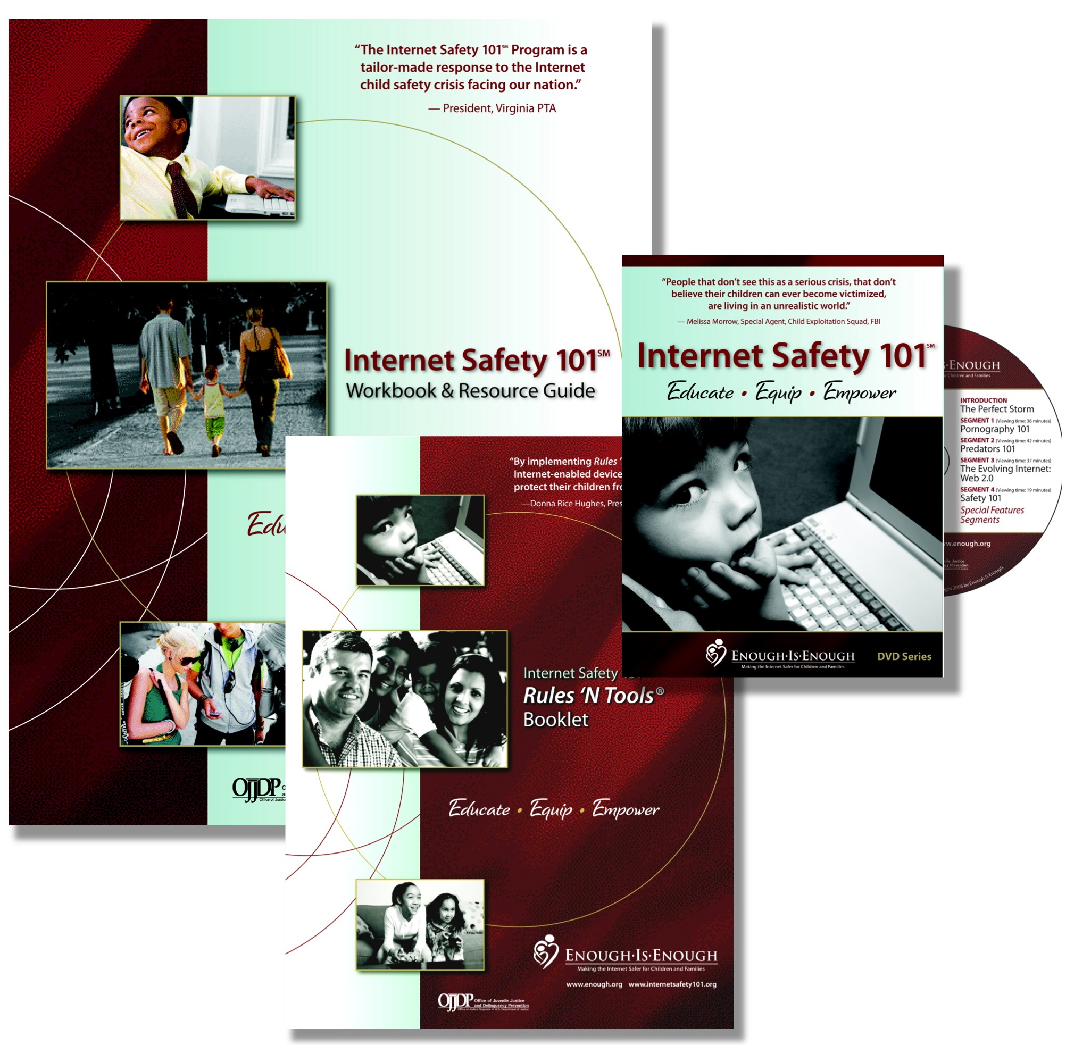

ORDER FORM

INTERNET SAFETY 101 PROGRAM

PURCHASER’S INFORMATION
Last Name |  |  |  |  | First |  |  |  | M.I.
Organization:
Street Address |  |  |  |  |  |  |  |  | Apartment/Unit #
City |  |  |  |  | State |  |  |  | ZIP Code
Phone |  |  |  |  | E-mail Address
Quantity/Item |  |  |  | Total Price: |  |  |  | $

shipping information (if differENt than above)
Last Name |  |  |  |  | First |  |  |  | M.I.
Organization:
Street Address |  |  |  |  |  |  |  |  | Apartment/Unit #
City |  |  |  |  | State |  |  |  | ZIP Code

PAYMENT INFORMATon
Credit Card Type |  |  | Check Visa MasterCard American Express Discover
Credit Card No. or Check No. |  | Expiration Date: |  |  |  |  |  |  | Security Code:

Please make checks payable to ENOUGH IS ENOUGH
FOR OFFICE USE ONLY

□ Databases
□ Letter
□ Kit Sent _________
□ Payment Processed _______

ENOUGH IS ENOUGH
746 Walker Road, Suite 116, Great Falls, VA 22066
Phone: 1-888-744-0004, Local: 703-476-7890 Fax: 703-620-8889
www.internetsafety101.org

A 501 (c)(3) organization
The Internet Safety 101 Workbook has an estimated value of $100.00, and under the rules and regulations of the IRS this amount must be subtracted from the total amount of your contribution and the balance is the amount you may claim as a charitable contribution, as allowed pursuant to 26 USC § 170.

